A TECHNICAL REPORT ON STUDENTS INDUSTRIAL WORK EXPERIENCE SCHEME (SIWES)

HELD AT
STARBEST COMPUTER
UBA, BORNO STATE

TITLE PAGE
FROM: 7TH OCTOBER, 2024
TO: 25TH JANUARY, 2025

BY
SARAH DANIEL
(ST/CS/ND/23/159)

A SIWES REPORT SUBMITTED TO THE DEPARTMENT OF COMPUTER SCIENCE, SCHOOL OF SCIENCE AND TECHNOLOGY FEDERAL POLYTECHNIC, MUBI, ADAMAWA STATE, NIGERIA
IN PARTIAL FUFILMENT OF THE REQUIREMENTS FOR THE AWARD OF NATIONAL DIPLOMA (ND) IN COMPUTER SCIENCE

FEBRUARY, 2025

ATTESTATION
I Sarah Daniel hereby attest that I did my Industrial Attachment Program at Starbest Computer Uba between October 2024, to January 2025, and this report is prepared by me and submitted to the SIWES coordinator as required. I understand that all the information contained in this report are correct and will be penalized if found to be false. I also know that the SIWES coordinator may request for additional evidence as requested for reconciliation.

……………………………………… ………………………..
SARAH DANIEL DATE
(ST/CS/ND/23/159)

CERTIFICATION
This is to certify that Sarah Daniel with a registration number ST/CS/ND/23/159 undergoes his/her industrial training SIWES at Starbest Computer Uba. In partial fulfilment of the requirements for the award of National Diploma (ND) in computer science, Federal Polytechnic, Mubi, as certified by the undersign officer.

MR. HYALAMADA SIMON ……………………………… DEPARTMENTAL SIWES CO-ORDINATOR DATE

DEDICATION
I dedicate this report to God Almighty, who saw me through the period of my SIWES training programme and also to my family.

ACKNOWLEDGEMENTS
I wish to register my profound gratitude to God Almighty for the guidance and grace throughout my life.
I am grateful to the entire staff of Starbest Computer Uba for making my industrial training interesting, educative and worthwhile and also to my Departmental lecturers.
I also acknowledge my friends I am grateful for all their support. My regards to my amazing and supportive parents for their moral support in my educational pursuit.

TABLE OF CONTENT
Title Page i
Certification iii
Dedication iv
Acknowledgements v
Table Of Content vi
CHAPTER ONE: INTRODUCTION 1
1.1 Brief History Of Siwes 1
1.2 Aims And Objectives Of Siwes 2
1.3 Roles Of Student 2
1.4 Objectives Of The Report 2
CHAPTER TWO: HISTORY OF THE ORGANIZATION 3
2.1 Organizational Chart 3
2.2 Brief History Of The Organization 3
CHAPTER THREE: WORK EXPERIENCE I 4
3.1 Introduction To Software 4
3.2 Introduction To Microsoft Office 4
3.3 Procedure For Installing Microsoft Office From Drive 5
3.4 Introduction To Microsoft Word. 6
CHAPTER FOUR: WORK EXPERIENCE II 9
4.1 Describing Microsoft Excel Environment 9
4.2 Plotting Of Chart 9
4.3 How To Calculate Sum 9
4.4 Font Formatting 10
4.5 Inserting 10
4.6 Functions Of Excel 11
4.7 How To Insert Chart 11
4.8 What Is Coreldraw 12
4.9 Steps To Install Coreldraw 12
4.10 Steps On Creating New Design 12
CHAPTER FIVE: SUMMARY, CONCLUSION, AND RECOMMENDATIONS 15
5.1 Summary 15
5.2 Conclusion 15
5.3 Recommendation 15
Reference 16

CHAPTER ONE: INTRODUCTION

1.1 BRIEF HISTORY OF SIWES
SIWES was founded in 1973 by ITF (Industrial Training Funds) to address the problem of tertiary institution graduates' lack of appropriate skills for employment in Nigerian industries. The Students' Industrial Work Experience Scheme (SIWES) was founded to be a skill training programme to help expose and prepare students of universities, Polytechnics and colleges of education for the industrial work situation to be met after graduation.
This system facilitates the transfer from the classroom to the workplace and aids in the application of knowledge. The program allows students to become acquainted with and exposed to the experience required in handling and operating equipment and machinery that are typically not available at their schools.
Prior to the establishment of this scheme, there was a rising concern and trend among industrialists that graduates from higher education institutions lacked appropriate practical experience for employment. Students who entered Nigerian universities to study science and technology were not previously trained in the practical aspects of their chosen fields. As a result of their lack of work experience, they had difficulty finding work.
As a result, employers believed that theoretical education in higher education was unresponsive to the needs of labor employers. Thousands of Nigerians faced this difficulty till 1973. The fund's main motivation for establishing and designing the scheme in 1973/74 was launched against this context.
The ITF (Industrial Training Fund) organization decided to aid all interested Nigerian students and created the SIWES program. The federal government officially approved and presented it in 1974. During its early years, the scheme was entirely supported by the ITF, but as the financial commitment became too much for the fund, it withdrew in 1978. The National Universities Commission (NUC) and the National Board for Technical Education (NBTE) were given control of the scheme by the federal government in 1979. The federal government handed over supervision and implementation of the scheme to ITF in November 1984. It was taken over by the Industrial Training Fund (ITF) in July 1985, with the federal government bearing entire responsibility for funding.

1.2 AIM AND OBJECTIVES OF SIWES
The Industrial Training Fund’s Policy Document No. 1 of 1973 which established SIWES outlined the objectives of the scheme as:
- Provide an avenue for students in Institutions of higher learning to acquire industrial skills and experience in their respective courses of study.
- Prepare students for the Industrial Work situation they are likely to experience after graduation.
- Expose students to work methods and techniques of handling equipment and machinery that may not be available in their Institutions.
- Make the transition from school to the world of work easier; and enhance students’ networks for later job placements.
- Provide students with an opportunity to apply their knowledge to real work situations, thereby bridging the gap between theory and practice; and vi. Enlist and strengthen Employers’ involvement in the entire educational process; thereby preparing the students for employment in Industry and Commerce.

1.3 ROLES OF STUDENT
- Attend SIWES orientation programme before going on attachment.
- Comply with the establishment’s rule and regulation.
- Arrange living accommodation during the period of attachment.
- Record all training activity done and other assignment in the log book.
- Complete SPEI from ITF, FORM 8 and get it endorsed by the employer for submission to the ITF.

1.4 OBJECTIVES OF THE REPORT
The objectives of the SIWES report are;
- To make thorough explanation of the work done during my four-month industrial training.
- To fulfill the requirement for national diploma in computer science.
- To contribute to the body of knowledge and to enhance the understanding of the writer about a similar or same job.

CHAPTER TWO: HISTORY OF THE ORGANIZATION

2.1 ORGANIZATIONAL CHART
Figure 2.1: Organization Chart

2.2 BRIEF HISTORY OF THE ORGANIZATION
Starbest computer center, Uba is a fully indigenous Nigerian company that provides clients with quality, cost effective and innovative IT and security solutions. It is located in Uba of Hong LGA of Adamawa State. Created on 26th October, 2017. Starbest computer center, Uba. focuses on total client satisfaction. The Company has built reputable standard over the years from her vast technical knowledge and competence, in project management and execution. The organisations vision include to be a first choice Information and Communication Technology (ICT) company with the idea of rendering unmatchable excellent professional solution to their clients in line with emerging technology.

CHAPTER THREE: WORK EXPERIENCE I

3.1 INTRODUCTION TO SOFTWARE
Computer Software: Are computer programs in the form of instruction and commands, which tell or instruct the computer on the nature of the action to be performed. Two Categories of software are System Software and Application Software.
System Software: - These are programs designed, produced, and installed by the manufacturer of the computer hardware to enable the machines function according to their specification. For example, language translators, utilities programs and operating systems.
Application packages: - These are programs designed and written by programmers to enable the computer carry out specific tasks needed by the users. Examples are Microsoft Office Suite, Microsoft Encarta etc.

3.2 INTRODUCTION TO MICROSOFT OFFICE
Tools Needed: USB, Computer, Microsoft Office or Microsoft Office documents.
Make sure you have a healthy, running USB drive with sufficient storage space of atleast 2GB of Memory. Computer with running, healthy, with Microsoft Office installed on. Microsoft Office and License Key
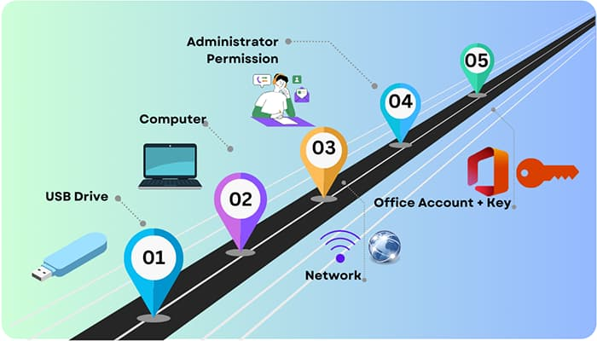
Figure 3.1: Tools Needed to Install Microsoft Office
Microsoft Office is a widely-used suite of productivity tools, like Word, Excel, and PowerPoint, relied on by many individuals and businesses. Installing it directly onto a computer is commonplace, but having it on a portable storage device like a flash drive has its advantages.

3.3 PROCEDURE FOR INSTALLING MICROSOFT OFFICE FROM DRIVE
First, make sure you have a valid license for the software. Then, insert the flash drive into your computer’s USB port and open the installation file. Select the option to install it on the flash drive, and follow the on-screen instructions.
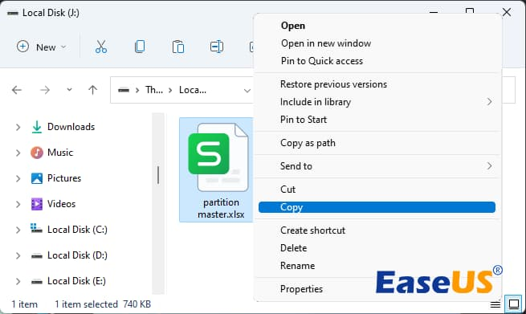
Figure 3.2: Copying and Pasting MS office to Drive
When the installation is done, you can safely remove the flash drive. To transfer Microsoft Office to another computer, insert the flash drive into a USB port and locate the folder containing the Microsoft Office files. Double-click on it to access its contents and run any of the included applications by double-clicking their icons.
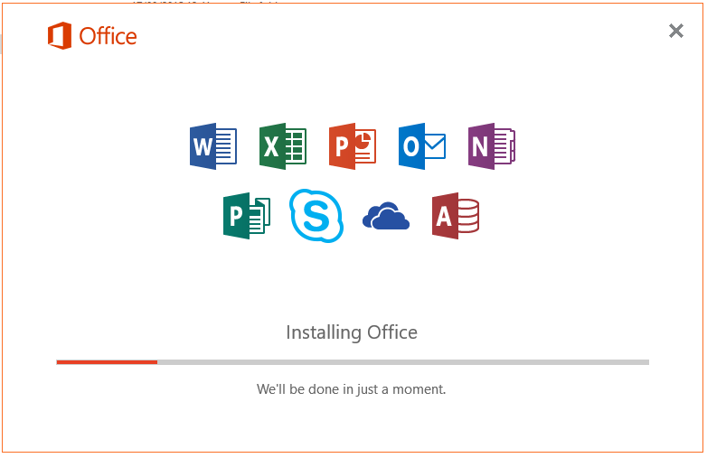
Figure 3.3: office Installation- Page

3.4 INTRODUCTION TO MICROSOFT WORD.
Microsoft word is an application software used for typing, editing, storing, and printing of texts with the use of an electrochemical device called computer. It can also be defined as the act of manipulation characters to create a professional looking document through the computer with the help of an application software.
Some important Functions of Ms Word
- Typing: This is done by using the keyboard. The keyboard as it is known as input device. It has about 108 keys on it. There are five part of the keyboards namely: function keys e.g. f1-f12, computer keys e.g. Esc, ctrl, shift, e.t.c Typing keys A-Z, Dedicated keys e.g. page up, page down, Arrow keys and Numeric keypad.

Figure 3.4: Keyboard layout
- Editing. This is the act of correcting error (s) in a document. It is also involves rearranging the document so as to give a perfect, desire, and professional.
- Storing: This is the same thing as saving a document into the permanent memory so as to able to re-call it any other time. It is needed. this should always be done frequently so as to guide against frequently power failure which can shutdown the computer and erase any file that has not been saved.
- Printing: This is the act of getting the hard copy or the soft copy of the document through a device called a printer using paper.
Screen Element of Microsoft Word
Title Bar: A place where application name of the user appears.
Menu Bar: A place where all news name that is use to perform different task appear e.g. File, Edit, Format. e.t.c.
Formatting Bar: A place where icon that is used to change the attribute of our text e.g. B for bold, I for italic, U for underline e.t.c.
Standard Tool Bar: This bar show operation symbols that represent a command like new, open, save, print, print preview, copy, cut and so on.
Scroll Bar: it is denoted by the triangle icon and it is used to move page up and down, left and right.
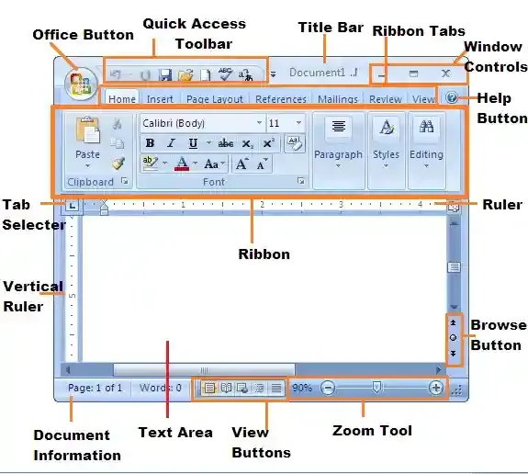
Figure 3.5: Element of Microsoft Word
How to Use the Superscript or Subscript buttons
- Select the text or number you want.
- Go to Home and select Superscript or Subscript .
Use keyboard shortcuts to apply superscript or subscript
- Select the text or number that you want.
- For superscript, press Ctrl, Shift, and the Plus sign (+) at the same time.
For subscript, press Ctrl and the Equal sign (=) at the same time. (Do not press Shift.)
Apply Superscript or Sub script from the font dialog box
- Select the text that you want to format as superscript or subscript.
- Go to Home, in the Font group, select the Font Dialog Box Launcher .
- Select Superscript or Subscript in the Effects group.
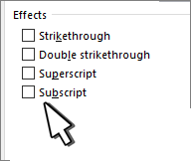.
Figure 3.6: Superscript or Subscript Dialog Box

Undo superscript or subscript formatting
To undo superscript or subscript formatting, select your text and press Ctrl+Spacebar.
Insert a superscript or subscript symbol
- On the slide, click where you want to add the symbol.
- Go to Insert > Symbol > More Symbols.
If your app isn't full screen, you may need to select Symbol again before More Symbols.
- In the Symbol box, select (normal text) from the Font drop-down list. It's the first item on the list.
- In the Symbol box, in the Subset drop-down list, select Superscripts and Subscripts.
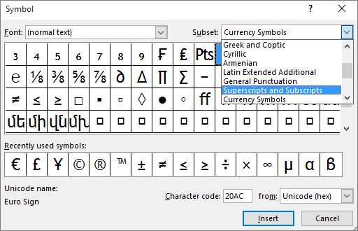
Figure 3.7: Symbol Dialog Box
In the Symbol box, select the symbol you want, press Insert, and then pick Close.

CHAPTER FOUR

WORK EXPERIENCE II

4.1 DESCRIBING MICROSOFT EXCEL ENVIRONMENT
Microsoft Excel is a spreadsheet program that was created by Microsoft and can be used on computers, tablets and cell phones. It allows people to conveniently share their work with others and organize data.
When Microsoft Excel is fully loaded into the computer memory, the following will be seen.
- The spreadsheet/worksheet
- Rows, Columns and cells
- The mouse pointer and cursor
- Working menu and bars

4.1.1 PLOTTING OF CHART
Charts are graphical representation of the data in a worksheet. They are appealing and makes it easy for users to set comparisons patterns and trends in data. For instance, rather than having to analyze several columns of worksheet you can see at a glance whatever the student in a given class actually make the required average to pass.
Steps in plotting chart:
- Select the whole data you want to produce it’s chart/graph.
- Click on insert on the menu bar
- On the submenu that appear, click on chart
- Another dialogue box will appear where you have to select the type of chart you want
- Locate and click on finish to complete the process. So the chart will be displayed.

4.1.2 HOW TO CALCULATE SUM
We use sum when calculating addition in excel. And before spreadsheet can respond to any mathematical command. It must be entered as an equation. Therefore, to enter a function as an equation. We must firstly start with “equals to “(=) sign.
Steps in calculating sum:
- Firstly, the data must be entered correctly as shown below
- Then keep your cursor on the location you want sum to be displayed by clicking the mouse there
- Type =sum and open bracket “(“then, click the mouse on the first cell you want to sum now type “:” click mouse on the last cell containing the data to be sum
- Then close the bracket “)”
- Press enter on the keyboard.

4.1.3 FONT FORMATTING
Font refers to every typed letter in the computer, while the formatting simply implies beautifying e.g. colouring, bolding, italic, underlining etc.
Steps in formatting text:
- Select the data by simply clicking on the cell
- Click on format on the menu bar
- Click on the cells on the submenu displayed
- On another box that appears, locate and click on font
- Use the mouse to scroll through the fonts dialogue box and click the mouse on the desired fonts size, colour, type etc.
4.1.4 INSERTING ROWS AND COLUMN
In case you need to type a given line of data in a given rows and column, but discover it has been occupied by another data not worry, you can simply insert another row or column in the same place.
Steps in inserting rows and column:
- Keep your cursor where you want the row or column
- Click on insert on the menu bar
- On the submenu displayed, click on either row or column depending on your choice.
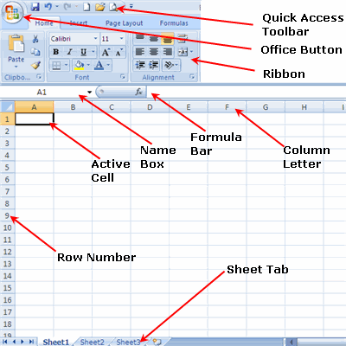
Figure 4.1: Microsoft Excel Environment and its Features.

4.1.5 FUNCTIONS OF EXCEL
Excel Performs the Following Functions
- Protection of documents
- Previewing of document before printing
- Formatting of text
- Perform some computation like; average, percentage, sum, subtraction etc.
- Picture formatting
- Cell formatting
- Importing of document from existing files

4.1.6 HOW TO INSERT CHART
- Highlight the work you want to insert a chart
- Without the total
- Click on insert
- Move the mouse to column or scatter chart
- Then select
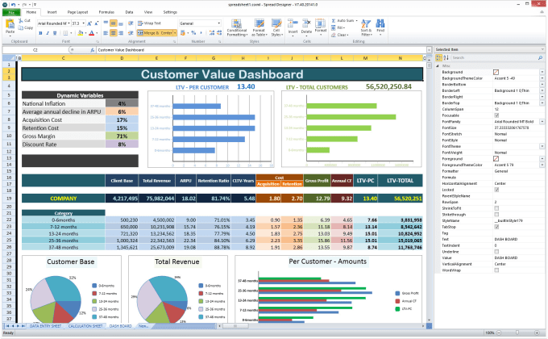
Figure 4.2: Chart insertion in an excel.

4.2 WHAT IS CORELDRAW
CorelDRAW is a vector graphics editor developed and marketed by Corel Corporation. It's primarily used for creating vector illustrations, logos, brochures, graphics for print and web, and other visual content.

STEPS TO INSTALL CORELDRAW
- Download the installation file from Corel's official website and run the installation file and follow the on-screen instructions.
- Enter your serial number when prompted and accept the license agreement.
- Wait for the installation to complete and Launch CorelDRAW.
- Activate the software if required.
- Start using CorelDRAW.

4.2.2 STEPS ON CREATING NEW DESIGN
Go to Welcome Screen and click on Get started > New Document
Inside the application window, press on File > New.
Fill the filename within the text box Name.
From the list box Preset destination, select an output destination to implement drawings:
CorelDRAW default: It can be used to apply default settings of CorelDRAW to create graphics that can be destined to print.
Default CMYK: It can be used to apply various settings to create graphics that can be destined for any commercial printing.
Default RGB: It can be used to apply the settings to create graphics. It can also be destined to print for any high-fidelity type printer.
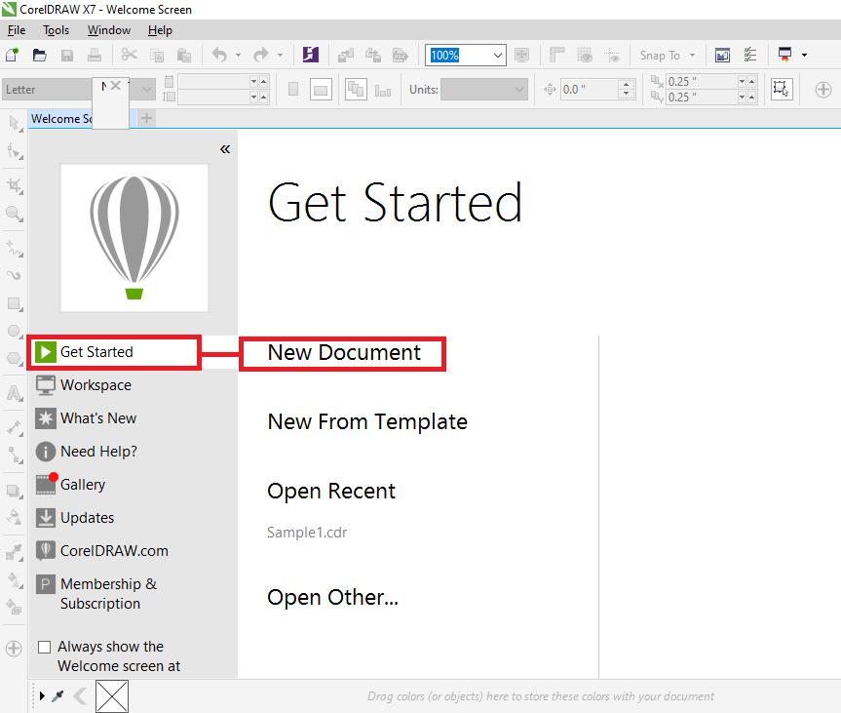
Figure 4.3: How to create New Document

4.2.3 FEATURES OF CORELDRAW
CorelDRAW offers a wide range of features including drawing tools, image editing capabilities, typography tools, layout features, and special effects. Some specific features include:
- Drawing tools like Pen, Bezier, and Shape tools for creating precise shapes and lines.
- Image editing tools for adjusting color, contrast, brightness, etc.
- Text tools for creating and editing text with various font options.
- Layout features like grids, guidelines, and alignment tools.
- Special effects such as drop shadows, transparency, and 3D effects.
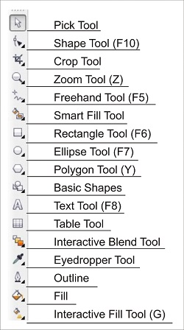
Figure 4.4: CorelDraw Tools bar
Redoing, and undoing actions
We can undo any action that we perform in the drawing, beginning with some most recent operations. If we do not like the undoing any operations result, we may redo it. Some essential operations are used to objects, like rotating, moving, filling, and stretching, which may be repeated for creating powerful visual effects.
Scrolling and zooming
We can modify the drawing view by zooming-in for a closer appearance or by zooming-out for more drawing appearance. We can experiment along with the zoom option's variety to examine the detail amount we want.
We can zoom out and in while we are panning, and we can pan at the time we are zooming. We can ignore having to substitute between any two tools.
Previewing drawings
We can preview the drawing to look at how it would appear if exported and printed. If we preview any drawing, the objects over the page of drawing and in an immediate place of a drawing window will be displayed and we can see every layer that can be set for printing inside an Object manager.
Saving drawings
The file format of CorelDRAW (CDR) can be used to save the drawings. It is compatible with an application's latest version.
To save the drawing
  - Press File > Save as.
  - Fill the filename within the box of File name.
  - Locate this folder where we wish to save our file.
When we wish to save any drawing to the vector file format, select the file format through the list box of Save as type.
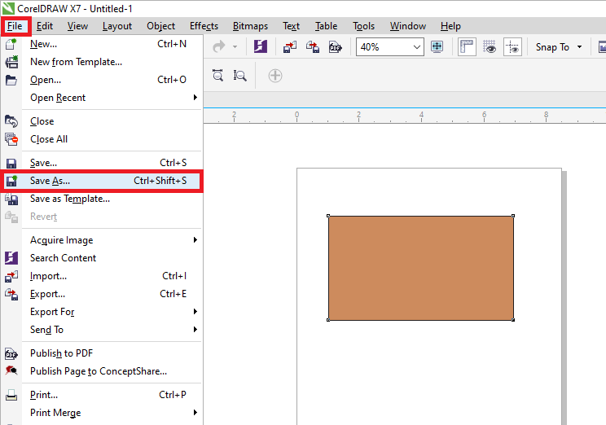
Figure 4.4: How to save a document

CHAPTER FIVE

SUMMARY, CONCLUSION, AND RECOMMENDATIONS

5.1 SUMMARY
The relevance of SIWES program cannot be over emphasized considering the fact that it has significantly reduced the gap between my theoretical and practical knowledge about the practical exercise gave me the opportunity to see myself in real life working condition. It also gave me the opportunity to broaden my thinking abilities, display the things that I have learnt and put most of them into practice. The challenges of modern industrial technological environment it has automatically changed my view about life and to relate with co-workers in general. The firm at large has taught me how to be independent of my own to be conscious in that I do.

5.2 CONCLUSION
The Student Industrial Work Experience (SIWES) has been of great benefit to me for it enables me acquiring more experience. I have successfully finished my attachment.
I was able to put the theory acquired (in school) into practical during the four (4) months attachment.
Finally, I want to use this opportunity to thank the federal government of Nigeria for organizing the student industrial Work Experience Scheme (SIWES) program for the benefit of the Nigeria science students.

5.3 RECOMMENDATIONS
As a student who has undergone the SIWES program, the following recommendation is made:
- The school should make SIWES programmed available to all department in the institution to give every student the opportunity to acquire practical knowledge of his idea of study.
- The school should ensure that student on the SIWES are attached to organization or division relevant to their course of student.
- The government should pay more attention or priority on the SIWES programmed because through such programmed students experience what they have learnt in the labour market.
- I equally suggest that schools should ensure that supervisors sent to supervise student on SIWES programmed get to every nooks and crannies of the country, this is to enable them know actually if student are really partaking in the programmed.

REFERENCE
Chukwurah, C. (2007) “Implement of Students Work Experience Scheme (SIWES) in Nigerian University”. Retrieved September 26, 2012 from.
Mathias G. (2022) Lecture note for SIWES and basic computer knowledge. Mazaga Press. Abia, Nigeria.
Nevin, A. (1990). The changing of teacher education special education. Teacher Education and Special Education: The Journal of the Teacher Education Division of the Council for Exceptional Children, 13(3-4), 147-148
Wodi, S. W. and Dokobo, A. (2009). Appraisal of Student industrial Work Experience Scheme (SIWES) in tertiary institution. European Journal of social science, 7(3)42-51. Eng. Enoch Maintenance Engineer AUN.
APPENDICES A
Graph Chart








